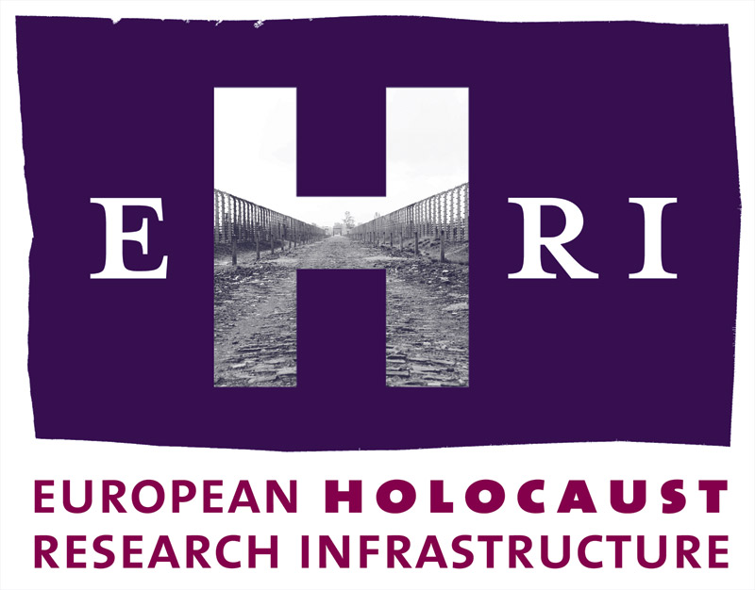
European Holocaust Research Infrastructure
Theme [INFRA-2010-1.1.4]
GA no. 261873

Deliverable
D.8.6

Publications

Reto Speck, NIOD Institute for War, Holocaust and Genocide Studies
Conny Kristel, NIOD Institute for War, Holocaust and Genocide Studies
Petra Drenth, NIOD Institute for War, Holocaust and Genocide Studies

Start: September 2012
Due: September 2013
Actual: January 2014

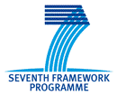

Document Information

Project URL | www.ehri-project.eu
Document URL | n/a
Deliverable | D8.6 Publications
Work Package | WP8
Lead Beneficiary | 1 – NIOD
Relevant Milestones | MS3
Nature | R
Type of Activity | COORD
Dissemination level | PU
Contact Person | Dr Reto Speck  King’s College London  Centre for e-Research  26-29 Drury Lane  London WC2B 5RL  reto.speck@kcl.ac.uk
Abstract  (for dissemination) | This deliverable summarises EHRI's publication activities from the start to the project to the present. It provides details about all EHRI-related publications in magazines, scholarly journals, edited books and conference proceeding, as well as about papers read at conferences.  This is the second iteration of the publication deliverable, providing an overview of EHRI publication activities since the start of the project until January 2014.
Management Summary  (required if the deliverable exceeds more than 25 pages) | N/a

Table of Content

1 Introduction and background 4
2 EHRI website and newsletters 5
3 Articles in magazines journals, conference proceedings, edited books 5
4 Conference papers 6
5 Organisation of conferences 8

Introduction and background
As outlined in the European Holocaust Research Infrastructure (EHRI) Publicity & Dissemination Strategy, the key objectives of work package (WP) 8 are to "position the project", "to explain its scope and potential impact", "to stimulate active take up and use of EHRI", "to disseminate results to key stakeholders and users" and "to explain the value and promote integration of research infrastructures".

A series of publications is a key ingredient in achieving these objectives. By publishing the background, objectives and results of our work in suitable formats across a variety of outlets that target all of the project's stakeholders, we ensure appropriate dissemination of EHRI’s mission and its scholarly achievements.

The present deliverable gives an account of our publication activities since the inception of the project in Autumn 2010 to the present. It contains details of EHRI-related publications across four different formats and media: articles published on the EHRI website and in EHRI newsletters; formal publications in magazines and various scholarly outlets; and presentations of papers at conferences.

The details provided here demonstrate that EHRI has been very successful in publishing across all of the main research areas in which it is active: history, archival science and e-Research. They also indicate that we have sought to reach general interest readers and highly-specialised domain experts alike with our publications. The high proportion of publications featuring multiple authors from different institutions, finally, goes to show that EHRI’s efforts to foster new relationships among different institutions and disciplinary areas are bearing fruit.

The publications listed in this deliverable have been authored by members across the EHRI consortium with WP8 fulfilling a co-ordinating function. WP8 will continue to undertake this function, and a final iteration of this deliverable will be produced in month 54 of the project.

EHRI website and newsletters
The EHRI website and newsletter have been used extensively to disseminate short and concise information. Website content has been targeted at all three subject communities and has been tailored toward both general readers and specialists.

The website at www.ehri-project.eu has been online since the start of the project in October 2010. It has been regularly updated with information about the project’s aims and objectives, news items detailing progress and announcements about EHRI events and surveys. The website is also used to disseminate some of our substantive research results such as the National Reports. The website has been a very successful dissemination channel, attracting more than 1,000 unique visitors each month in 2013.

We have periodically sent out EHRI newsletters providing a summary of new website content to a contact list of approximately 1,000 recipients. Since the first issue in January 2011, we have produced eleven newsletters. In addition, two expert newsletters supplementing the interdisciplinary workshops organised by work package 6 have been produced: the first in February 2012 on ‘’Holocaust Victims’ Names’’, the second in May 2013 on “Holocaust Testimonies”.

Articles in magazines journals, conference proceedings, edited books
Short overview articles aimed at general interest readers and published in magazines and newsletters, as well as formal specialist publications in journals, edited books, and conference proceedings are a particular focus of our current activities.

The list below contains detail of papers that have already been published or are in press.

Anderson, Sheila, and Tobias Blanke. "Intermediating the Human and Digital: Researchers and the European Holocaust Research Infrastructure." EHRI Working Papers (2013).

Benardou, Agiatis, and Costis Dallas. Defining User Requirements for Holocaust Research Infrastructures and Services in the EHRI Project In iConference 2012. ACM2012. Toronto, Canada, 2012.

Benardou, Agiatis, Panos Constantopoulos, and Costis Dallas. "An Approach to Analyzing Working Practices of Research Communities in the Humanities." International Journal of Humanities and Arts Computing 7, no. 1-2 (2013).

Bennett, Giles. "The European Holocaust Research Infrastructure (EHRI)." The Bulletin of the Carolyn and Leonary Miller Center for Holocaust Studies 16 (2012).

Blanke, Tobias, and Conny Kristel. "Integrating Holocaust Research." International Journal of Humanities and Arts Computing 7, no. 1-2 (2013).

Blanke, Tobias, Michal Frankl, Conny Kristel, Reto Speck, and Veerle Vanden Daelen. "The Past and the Future of Holocaust Research: From Disparate Sources to an Integrated European Holocaust Research Infrastructure." In Evolution der Informationsinfrastruktur: Forschung und Entwicklung als Kooperation von Bibliothek und Fachwissenschaft, edited by Heike Neuroth, Norbert Lassau and Andrea Rapp. Goettingen (2013), pp. 157-177. .

Kahn, Rebecca. "The EHRI Project: building an online archive for European Holocaust Research." SCONUL Focus 52 (2011).

Kefer, Tamara. "Vergleichende Findmittelstudien im Rahmen des EU-Projektes 'European Holocaust Research Infrastructure'. Workshop beim Internationalen Suchdienst (ITS) in Bad Arolsen." Archivnachrichten aus Hessen 13/1 (2013): 57-59.

Kühnel, Karsten. "Archivportal und Forschungsplattform zum Holocaust." Archivnachrichten aus Hessen 2 (2012).

Rodriguez, Kepa Joseba, Mike Bryant, Tobias Blanke, and Magdalena Luszczynska. Comparison of named entity recognition tools for raw OCR text In KONVENS. Vienna , 2012.

Speck, Reto, and Petra Links. "The Missing Voice: Archivists and Infrastructures for Humanities Research." International Journal of Humanities and Arts Computing 7.1-2 (2013).

Conference papers
Papers read at conferences in the areas of archival science, history and e-research is another important publication avenue for EHRI. In addition to major contributions to conferences detailed below, members of the consortium have also been very active in presenting EHRI's work at meetings of steering committees and working groups of a host of relevant institutions, organisations and projects such as the Academic Working Group of the International Holocaust Remembrance Alliance , the Association of Memorial Sites Libraries, Dasish and DARIAH-EU.

Anderson, Sheila. "Keynote address." In KVAN-dagen. Amsterdam: Annual conference of the Koninklijke Vereniging van Archivarissen in Nederland/Royal Society of Dutch Archivists, 2013.

Anderson, Sheila, Veerle Vanden Daelen, and Reto Speck. "Transcending the Archive? The Digital Environment as a Force for Change." In Annual Conference of the International Council of Archives: Accountability, Transparency and Access to Information. Brussels, 2013.

Benardou, Agiatis. "Challenges, outcomes and remarks on information practices and user needs in the humanities. The cases of the EU projects DARIAH and EHRI." In Technothings meeting. BIOS Athens, 2011.

Bennett, Giles. "European Holocaust Research Infrastructure." In Jüdische Geschichte digital - Workshop. Hamburg, 2013.

Blanke, Tobias, Richard Connor, Mark Hedges, Conny Kristel, Mike Priddy, and Fabio Simenoni. "Creating general-purpose virtual environments for (digital) archival research ." In Digital Humanities . Stanford California : Alliance of Digital Humanities Organizations, 2011.

Blanke, Tobias, Mike Bryant, Reto Speck, and Conny Kristel. "Information Extraction on Noisy Texts for Historical Research." In Digital Humanities. Hamburg: Alliance of Digital Humanities Organizations, 2012.

Bryant, Mike, Tobias Blanke, and Mark Hedges. "Back to our Data - Experiments with NoSQL Technologies in the Humanities." In IEEE Big Data 2013. Silicon Valley, USA, 2013.

Dallas, Costis. "Classical Philology, Text-based and Holocaust Studies Facing Digital Research Infrastructures: From Practice to Requirements." In SDH 2011: Supporting Digital Humanities. Universtiy of Copenhagen, 2011.

Frankl, Michal. "(Re)Constructing the Archive of the Terezín/Theresienstadt Ghetto." In Heritage Recovered. The Holocaust in Jewish Archives - An International Comparison. Vienna, 2013.

Links, Petra, and Ivo Zandhuis. "Kies voor de geesteswetenschapper! Naar een virtuele studiezaal langs de Digital Humanities." In Annual conference of the Koninklijke Vereniging van Archivarissen in Nederland/Royal Society of Dutch Archvists. Amsterdam, 2013.

Luyten, Dirk. "Privacy in an international historical research environment: the example of the European Holocaust Research Infrastructure (EHRI) project." In Public Conference at the Research Centre Information, Law and Society : Privacy at the crossroads of Sociology, Philosophy, History and Law (CRIDS), 2012.

Schellenbacher, Wolfgang, and Bela Rasky. "European Holocaust Research Infrastructure." In Tagung Europäische Forschungsinfrastrukturen in den Geisteswissenschaften. Österreichische Akademie der Wissenschaften, Wien: CLARIN-AT and DARIAH-AT, 2012.

Speck, Reto, and Petra Links. "Research infrastructures and archival inter-mediation." In Building infrastructures for archives in a digital world. Dublin: APEx, 2013.

Vanden Daelen, Veerle. "Connecting Collections, Institutions & Researchers." In ITF pre-conference New Directions in Holocaust Research with a special emphasis on Educational applicability. Brussels Palais d'Egmont, 2012.

Vanden Daelen, Veerle. "Connecting Collections, Collection-holding Institutions and Researchers." In 5th Contact Day Jewish Studies on the Low Countries. University of Antwerp, 2012.

Vanden Daelen, Veerle. "Making sure the data fit the researchers. Data identification and investigation in European Holocaust Research Infrastructure (EHRI)." In Cultural Heritage, Creative Tools and Archives. National Museum of Denmark, Copenhagen, 2013.

Vanden Daelen, Veerle. "User Requirements and Data Integration in European Holocaust Research Infrastructure (EHRI) - the Greek Case." In European Social Science History Conference. Vienna, In Press.

Organisation of conferences
Together with DARIAH and TextGrid, EHRI co-organised a major international conference on the "Public History of the Holocaust", which took place in Berlin on 9 July 2013. The conference brought together policy makers and researchers to discuss the challenges for historical research on the Holocaust in the age of the internet, and the possibilities of meeting these challenges through new forms of digital research infrastructures (see http://www.ehri-project.eu/public-history-holocaust for details).

EHRI WP7 ("Expanding EHRI") is currently organising an international conference on "Holocaust Documentation in Eastern Europe" that is to take place in Krakow on 20-21 May 2014. The conference will bring together researchers and archivists. It will address the challenges researchers and collection holders face when undertaking research on the Holocaust in Eastern Europe.

Tellegen, Jan Willem "D8.1 Publicity & dissemination Strategy", EHRI Deliverable D8.1, June 2011.

