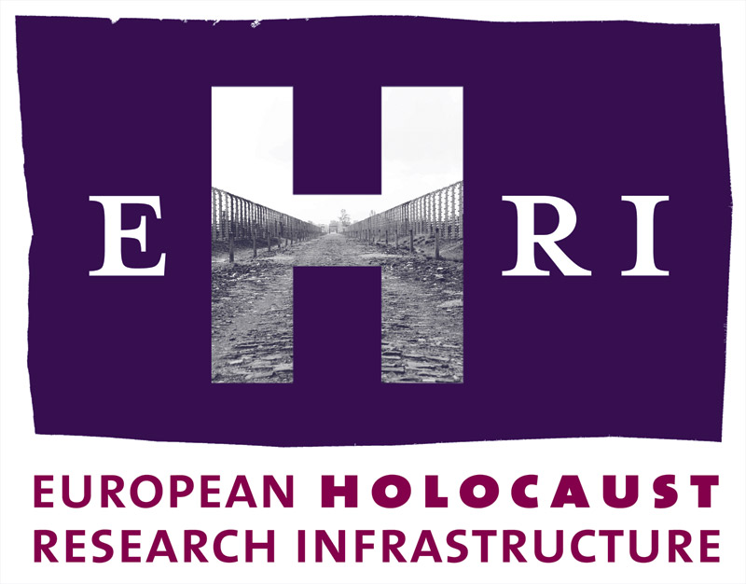

European Holocaust Research Infrastructure
Theme [INFRA-2010-1.1.4]
GA no. 261873

Deliverable
D6.4

Annual Methodological Online Newsletter – Second Issue
Haim Gertner, Hillel Solomon
Yad Vashem

Start: July 2012
Due: December 2012
Actual: April 2013

Note: The official starting date of EHRI is 1 October 2010. The Grant Agreement was signed on 17 March 2011. This means a delay of 6 months which will be reflected in the submission dates of the deliverables.

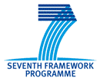

Document Information

Project URL | www.ehri-project.eu
Document URL
Deliverable | D6.4 Annual Methodological Online Newsletter – Second Issue
Work Package | WP6
Lead Beneficiary | 5 YV
Relevant Milestones | MS1
Nature | R
Type of Activity | COORD
Dissemination level | PU
Contact Person | Dr. Haim Gertner haim.gertner@yadvashem.org.il  + 972-2-6443721
Abstract  (for dissemination) | Publication of a e-newsletter of experts in order to share and disseminate knowledge and new insights and to organize a continuous exchange of knowledge and views between experts in methodological fields of Holocaust research (second of 4 annual newsletters).

Table of Contents

Annual Methodological Online Newsletter - Introduction 4
D6.4 – Annual Methodological Online Newsletter – Second Issue 5
Annual Online Newsletter – Second Issue – Image and Link 6

Annual Methodological Online Newsletter

Introduction:
Holocaust research is an interdisciplinary field. Therefore it demands the application and dissemination of a very wide range of methodologies. The aim of this network activity is to facilitate exchanges of information between experts of various subfields and through their cooperation to create the methodological bases of Holocaust remembrance and research.
One of the aims of the project is to create ties between the experts of a special field within the research of the Holocaust and also between the experts of related areas, mainly in other EU infrastructure projects like DARIAH etc. This approach aids not only the development of Holocaust research but also the particular discipline in general.
In addition to a series of expert workshops on a range of subfields of Holocaust research and documentation, WP6 publishes an annual e-newsletter for experts in Holocaust documentation. The aim of the newsletter is to share and disseminate knowledge and new insights, and to organize a continuous exchange of knowledge and views between experts in methodological fields of Holocaust research. This newsletter represents an additional complementary networking channel to the expert workshops.
The e-newsletter is published and disseminated in cooperation with WP8, WP19 and WP20.

D6.4 – Annual Methodological Online Newsletter – Second Issue
The second issue of the WP6 e-newsletter focuses on Survivor Testimonies, leading with a report on the EHRI expert workshop: "Truth and Witness: An International Workshop on Holocaust Testimonies", held at the Wiener Library in London in April-May 2012.
Two articles were prepared for the newsletter by workshop participants Neal Guthrie and Mark Zaurov, the latter for the "Opinion" section. A further three articles were written especially for the newsletter (Jan Rietama, Irena Steinfeldt and Haim Saadoun). In addition the newsletter links to two articles from USC - Shoah Foundation, an interview from the International School for Holocaust Studies at Yad Vashem, and a review of Alan Rosen's book The Wonder of Their Voices: The 1946 Holocaust Interviews of David Boder. A special section contains articles from USC - Shoah Foundation and the International School for Holocaust Studies at Yad Vashem on the use of Holocaust survivor testimony in Holocaust Education.
The Events – EHRI Workshops section contains summaries of the "Truth and Witness" workshop as well as the "Early Attempts at the Historical Documentation of the Holocaust" workshop, which was held in Budapest in November, 2012. This section also contains information on the upcoming "Geography and Holocaust Research" workshop. Finally, the newsletter provides links to leading online testimony collections.
In cooperation with WP8, the newsletter is distributed initially to a diverse contact list comprising about 1,000 researchers, students, teachers, journalists, politicians and other interested persons. (This list, of course, includes the participants of the expert workshops conducted in the framework of WP6.) The newsletter is also available on the EHRI website.
Evaluation
The publication of the first annual e-newsletter was delayed by several months due to the late start of the EHRI project.
In comparison with the first issue, we had greater success in recruiting original articles for the newsletter. We will continue to enlist the assistance of WP6 workshop organisers in obtain articles from workshop participants and others, in coordination with the editor of the newsletter.

Annual Online Newsletter – Second Issue

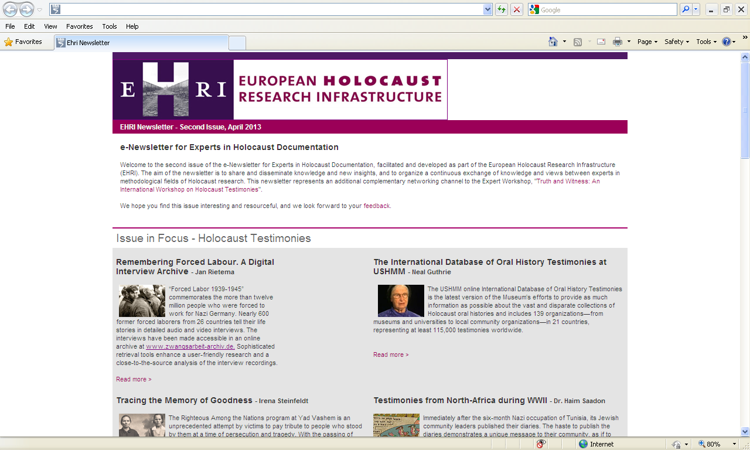

Link to newsletter:
http://www.ehri-project.eu/e-Newsletter-for-Experts-in-Holocaust-Documentation

