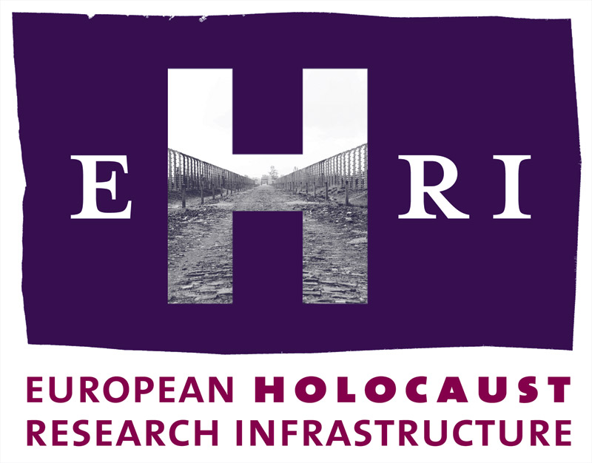

European Holocaust Research Infrastructure
Theme [INFRA-2010-1.1.4]
GA no. 261873

Deliverable
D6.2

Annual Methodological Online Newsletter
Haim Gertner, Hillel Solomon
Yad Vashem

Start: April 2011
Due: August 2011
Actual: January 2012

Note: The official starting date of EHRI is 1 October 2010. The Grant Agreement was signed on 17 March 2011. This means a delay of 6 months which will be reflected in the submission dates of the deliverables.

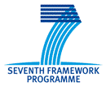

Document Information

Project URL | www.ehri-project.eu
Document URL
Deliverable | D6.2 Annual Methodological Online Newsletter
Work Package | WP6
Lead Beneficiary | 5 YV
Relevant Milestones | MS1
Nature | R
Type of Activity | COORD
Dissemination level | PU
Contact Person | Dr. Haim Gertner haim.gertner@yadvashem.org.il  + 972-2-6443721
Abstract  (for dissemination) | Publication of a e-newsletter of experts in order to share and disseminate knowledge and new insights and to organize a continuous exchange of knowledge and views between experts in methodological fields of Holocaust research (first of 4 annual newsletters).

Table of Contents

Annual Methodological Online Newsletter - Introduction 4
D6.2 – Annual Methodological Online Newsletter – First Issue 5
Annual Online Newsletter – First Issue – Image and Link 6

Annual Methodological Online Newsletter

Introduction:
Holocaust research is an interdisciplinary field. Therefore it demands the application and dissemination of a very wide range of methodologies. The aim of this network activity is to facilitate exchanges of information between experts of various subfields and through their cooperation to create the methodological bases of Holocaust remembrance and research.
One of the aims of the project is to create ties between the experts of a special field within the research of the Holocaust and also between the experts of related areas, mainly in other EU infrastructure projects like DARIAH etc. This approach aids not only the development of Holocaust research but also the particular discipline in general.
In addition to a series of expert workshops on a range of subfields of Holocaust research and documentation, WP6 publishes an annual e-newsletter for experts in Holocaust documentation. The aim of the newsletter is to share and disseminate knowledge and new insights, and to organize a continuous exchange of knowledge and views between experts in methodological fields of Holocaust research. This newsletter represents an additional complementary networking channel to the expert workshops.
The e-newsletter is published and disseminated in cooperation with WP8, WP19 and WP20.

D6.2 – Annual Methodological Online Newsletter – First Issue
The first issue of the WP6 e-newsletter focuses on the recovery of Shoah victims' names, leading with a report on the EHRI expert workshop: "Recording the Names", held at Yad Vashem in Jerusalem in July 2011. The newsletter includes several articles pertaining to this topic, notably two articles by participants in the names workshop: Krzysztof Antończyk on the digital repository of the Auschwitz-Birkenau State Museum, and Dr. Vladimir Adamushko on Belarus State Archives documents.
Additionally, the newsletter has a section on historiography, this time presenting an article by Prof. Guy Miron in which he provides an analysis of Holocaust scholarship and general Jewish history, and the respective places of each in the other field of inquiry. In the Events section of the newsletter there is a report on the second EHRI expert workshop: "The Holocaust and (Digital) Photographic Documentation, held at NIOD in Amsterdam in September 2011. (This topic will receive further attention in one of the upcoming newsletters.) Announcements of the two workshops that will take place in 2012 also appear in the newsletter.
In cooperation with WP8, the newsletter has been distributed to an initial diverse contact list comprising about 700 researchers, students, teachers, journalists, politicians and other interested persons. (This list, of course, includes the participants of the two expert workshops.)
Evaluation
The publication of the first annual e-newsletter was delayed by several months due to the late start of the EHRI project.
One problem encountered regarding the newsletter content is the recruitment of researchers, scholars and archivists who are prepared to write original articles for a newsletter of this type. Therefore it was decided that it will be the responsibility of the organisers of the upcoming two workshops to interview suitable participants and collect articles from the participants, in coordination with the editor of the newsletter.

Annual Online Newsletter – First Issue

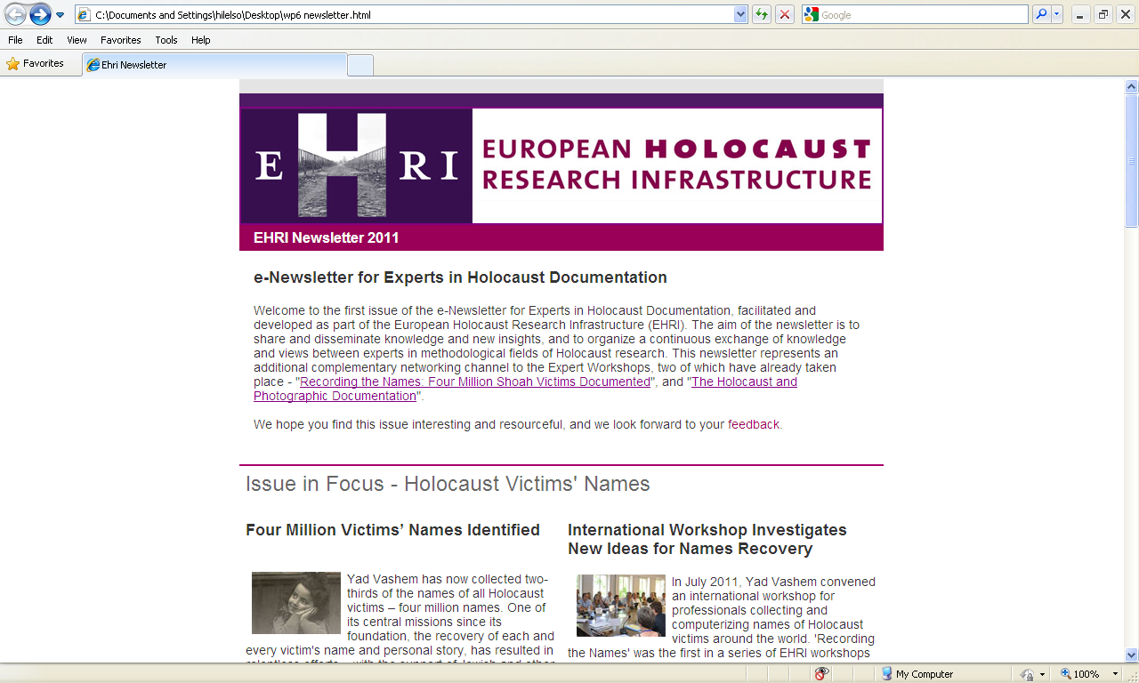

Double-click to open hyperlink

