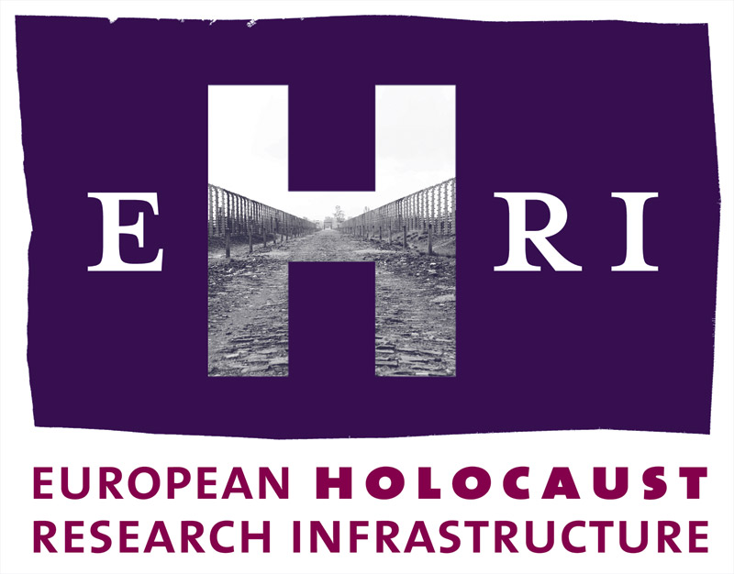

European Holocaust Research Infrastructure
Theme [INFRA-2010-1.1.4]
GA no. 261873

Deliverable
D14.1

48 weeks access

Work Package 14:
Karen Taieb, Mémorial de la Shoah

Start: October 2010
Due: December 2014
Actual: December 2014

Note: The official starting date of EHRI is 1 October 2010. The Grant Agreement was signed on 17 March 2011. This means a delay of 6 months which will be reflected in the submission dates of the deliverables.

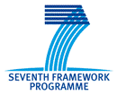

Document Information

Project URL | www.ehri-project.eu
Document URL | [www……]
Deliverable | 14.1 48 weeks access
Work Package | 14
Lead Beneficiary | P15 MS
Relevant Milestones | MS4
Nature | O
Type of Activity | SUPP
Dissemination level | PU
Contact Person | Karen Taieb, karen.taieb@memorialdelashoah.org, +33 1 53 01 17 33
Abstract  (for dissemination) | Between 2012 and 2014, 48 weeks of Trans-national Access at Mémorial de la Shoah were offered to users working in the field of Holocaust research.
Management Summary  (required if the deliverable exceeds more than 25 pages) | Not applicable

48 weeks access

Between 2012 and 2014, EHRI offered 48 weeks of Trans-national Access at Mémorial de la Shoah (MS) to users working in the field of Holocaust research. For the selection procedure and the evaluation, please see DL 4.1, 4.2, 4.3. and 4.
Each EHRI-Fellowship lasted four weeks, while offering the users to extend their stay subject to coordination with MS at their own expense.

2012
Frida Bertolini (Italy), Ph.D. Student, University of Bologna, “Forgery and Denial: Affairs, Historians and Public Opinion”
Nathan Kurz (IL), Ph.D. Candidate, Haifa University, “'A Sphere Above the Nations'? Human Rights and the Limits of Jewish Transnational Politics, 1945-1975”
Iris van Ooijen (The Netherlands), Ph.D. Student, VU University of Amsterdam, “Topography of Memory: Representations of the Holocaust at Westerbork and Drancy”
Jennifer L. Rodgers (Germany), Ph.D. candidate, Universität Heidelberg, “From the 'Archive of Horror' to the 'Shop Window of Democracy': The International Tracing Service and the Transatlantic Politics of the Past in the Cold War Era.”

2013
Asya Darbinyan (Armenia), Senior Research Fellow, Armenian Genocide Museum-Institute, “Comparative Study in Humanitarian Assistance for Armenians during the Genocide and for Jewish Communities during the Holocaust”
Irina Ognyanova (Bulgaria), Assistant Professor, Bulgarian Academy of Sciences, “Nationalism and National Policy in Independent State of Croatia (1941-1945)”
Sulyok, Izabella (Hungary), PhD Student, University of Szeged, “’I decide who is a Jew.’ A comparative analysis on the exemption of Jews from the anti-Jewish measures in France and Hungary, 1938-1944”
Alexandra Tcherkasski (Germany), PhD Student, Bochum University, Die Stellung der Holocausterfahrung im Rahmen der sowjetischen Erinnerungspolitik nach dem „Großen Vaterländischen Krieg“

2014
Edy Cohen (Israel), research fellow, Bar-Ilan University, "Nazis and Axis Propaganda in Mandatory Palestine and the Arab World, 1933-1945"
Luca Fenoglio (United Kingdom), PhD student, University of Edinburgh, “The ‘everyday life’ of persecution: Italian diplomats and police officers, and the anti-Jewish policy in Italian-occupied France”
Anna Marczisovszky (Hungary), PhD candidate, Eötvös Loránd University Budapest, “’Try to look. Just try and see.’ – In Search of a Haunting Memoir”
Aleksandra Szczepan (Poland), PhD student, Jagiellonian University Kraków, ”Post-Holocaust, Post-dependence, Post-memory: Negotiating Jewish Identity in the Post-Communist Central Europe”

