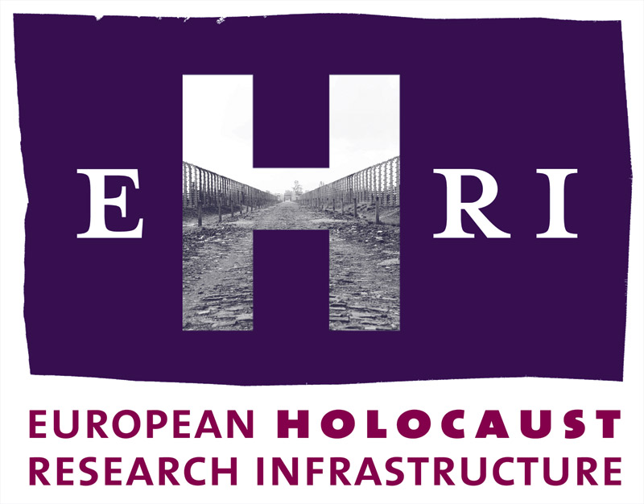

European Holocaust Research Infrastructure
Theme [INFRA-2010-1.1.4]
GA no. 261873

Deliverable
D11.1

36 weeks access

Work Package 11:
Frank Bajohr, Institut für Zeitgeschichte (IfZ), Work Package Leader
Giles Bennett (IfZ)

Start: October 2010
Due: December 2014
Actual: December 2014

Note: The official starting date of EHRI is 1 October 2010. The Grant Agreement was signed on 17 March 2011. This means a delay of 6 months which will be reflected in the submission dates of the deliverables.

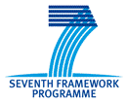

Document Information

Project URL | www.ehri-project.eu
Document URL | [www……]
Deliverable | 11.1 36 weeks access
Work Package | 11
Lead Beneficiary | P4 IfZ
Relevant Milestones | MS4
Nature | O
Type of Activity | SUPP
Dissemination level | PU
Contact Person | Giles Bennett, bennett@ifz-muenchen.de, +49 (0)89 552790712
Abstract  (for dissemination) | Between 2012 and 2014, more than 36 weeks of Trans-national Access at the Institut für Zeitgeschichte were offered to users working in the field of Holocaust research.
Management Summary  (required if the deliverable exceeds more than 25 pages) | Not applicable

36 weeks access

Between 2012 and 2014, EHRI offered more than 36 weeks of Trans-national Access at the Institut für Zeitgeschichte (IfZ) to users working in the field of Holocaust research. For the selection procedure and the evaluation, please see DL 4.1, 4.2, 4.3. and 4.4. Remaining funds were invested in two additional 4 week EHRI-Fellowships in 2014.

Each EHRI-Fellowship lasted four weeks, while offering the users to extend their stay subject to coordination at the IfZ at their own expense.

2012
Lida Barner (UK), Postgraduate Research Student, University College London, “Intellectual Plunder: Aryanisation and Restitution of 'Jewish Patents' in National Socialism”
Marko Carynnyk (NL), Research Fellow, NIOD, “Furious Angels: Ukrainians, Jews, and Poles in the Summer of 1941”

2013
Elizabeth Büttner (PL), PhD student, Jagiellonian University Krakow, “German Prisoners in the Auschwitz Concentration Camp”
Adam Gellert (HU), researcher, Holocaust Memorial Center Budapest, “The Deportation and Massacre of Hungarian Jews in Ukraine in the Summer of 1941”

2014
Devra Katz (Israel), graduate student, University of Haifa, “Emotions in Stutthof: An Analysis of the Social Function of Emotions in a Prisoner Society”
Aleksandra Loewenau (United Kingdom), postdoctoral research assistant, Oxford Brookes University, “Rebuilding Lives of Jewish Survivors of Medical Experiments at Auschwitz: A Comparative Study”
Matt Lawson (United Kingdom), PhD candidate, Edge Hill University, “Film Music of German Holocaust cinema”
Katarzyna Person (Poland), assistant professor, Jewish Historical Institute / Warsaw, “Polish-Jewish Relations in Germany in the Immediate Postwar Period”

