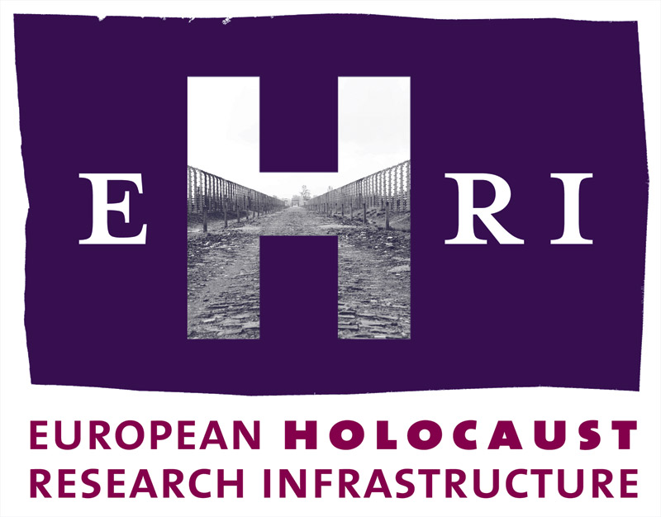

European Holocaust Research Infrastructure
Theme [INFRA-2010-1.1.4]
GA no. 261873

Deliverable
D10.1

36 weeks access

Work Package 10:
Karel Berkhoff, NIOD Institute for War, Holocaust and Genocide Studies

Start: October 2010
Due: December 2014
Actual: December 2014

Note: The official starting date of EHRI is 1 October 2010. The Grant Agreement was signed on 17 March 2011. This means a delay of 6 months which will be reflected in the submission dates of the deliverables.

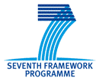

Document Information

Project URL | www.ehri-project.eu
Document URL | [www……]
Deliverable | 10.1 36 weeks access
Work Package | 10
Lead Beneficiary | P1 NIOD
Relevant Milestones | MS4
Nature | O
Type of Activity | SUPP
Dissemination level | PU
Contact Person | Dr. Karel Berkhoff, k.berkhoff@niod.knaw.nl, +31 (0)20 523 3800
Abstract  (for dissemination) | Between 2012 and 2014, 36 weeks of Trans-national Access at NIOD Institute for War, Holocaust and Genocide Studies were offered to users working in the field of Holocaust research.
Management Summary  (required if the deliverable exceeds more than 25 pages) | Not applicable

36 weeks access

Between 2012 and 2014, EHRI offered 36 weeks of Trans-national Access at NIOD Institute for War, Holocaust and Genocide Studies (NIOD) to users working in the field of Holocaust research. For details, such as the selection procedure and the judges, please see DL 4.1, 4.2, 4.3. and 4.4.

Each EHRI-Fellowship lasted four weeks, while offering the users to extend their stay subject to coordination with the NIOD at their own expense.

2012
Susanne Barth (Germany), Ph.D. Student, University of Oldenburg, “The Oberschlesische Hydrierwerke AG and the Auschwitz Subcamp of Blechhammer 1939-1945”
Linda Margittai (Hungary), Ph.D. Candidate, University of Szeged, “Holocaust in the Netherlands: the Fate of the Hungarian Jews”

2013
Katja Happe (Germany), Researcher, Freiburg University, “Die Geschichte der Judenverfolgung in den Niederlanden 1940-1945”
Roma Sendyka (Poland), Assistant Professor, Jagiellonian University Kraków, “Understanding Non-Sites of Memory (Non-Lieux de Mémoire)”

2014
Christine Kausch (Germany), doctoral student, University of Münster, “Zuflucht auf Zeit – Jüdische Flüchtlinge aus Deutschland in den Niederlanden 1933-1945”
Tatsiana Vaitulevich (Germany), PhD candidate, Georg-August-Universität Göttingen, “The Public Memory of the Holocaust in Post-War Netherlands and in Belarus”

